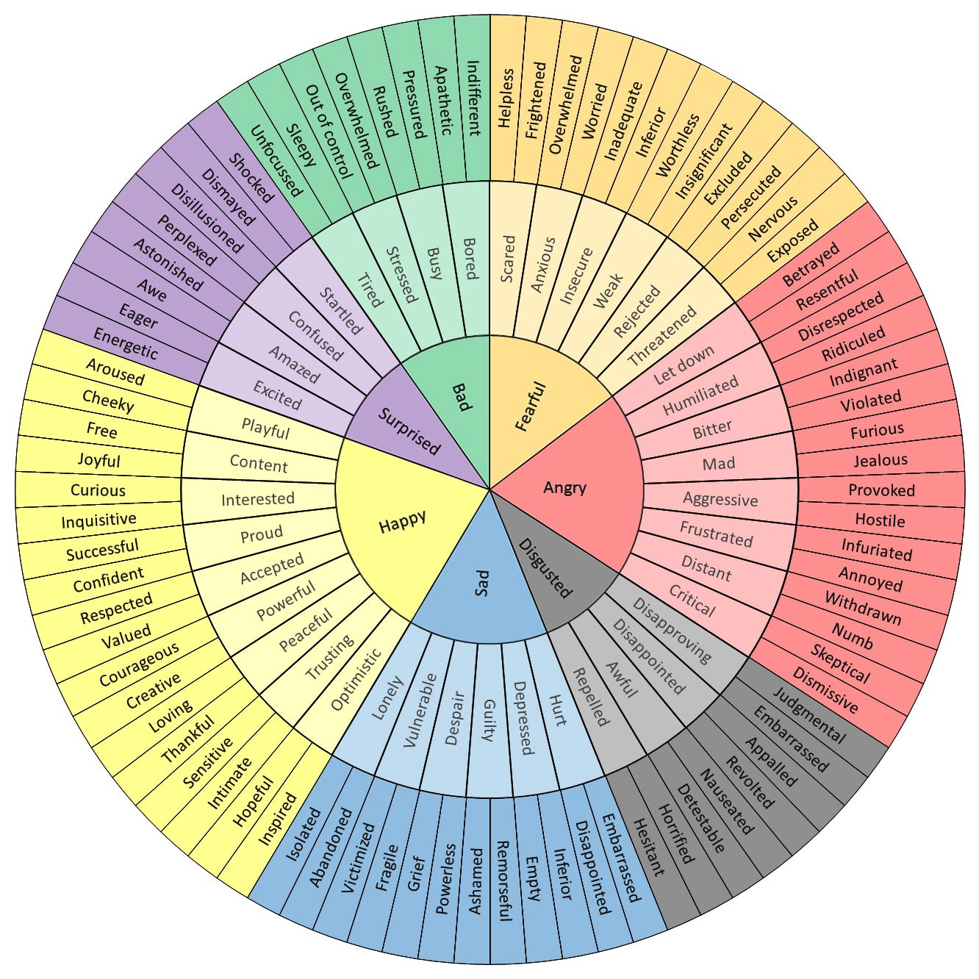
Image:
Emotional Words Wheel
via imgur

