Lesson Plan Package 3 – Controversial Issues
LP3 – Does Religion Unite or Divide people?
Views on Religion Handout
Instructions: Below there are 4 different sources of different views around whether religion unites or divides people. In small groups, use the questions on the PPT (copied below) to work through each of them, thinking critically about this information and how you engage with it. You can make notes on this handout or separately.
- What do you think of this opinion?
- What is this person’s worldview? Do we know?
- What part of this is factual? Which parts can we fact-check?
- Is there any bias here? Why / where / how?
- Is any of their language harmful?
- How does this match what you usually hear?

- General online comment

2. Newspapers

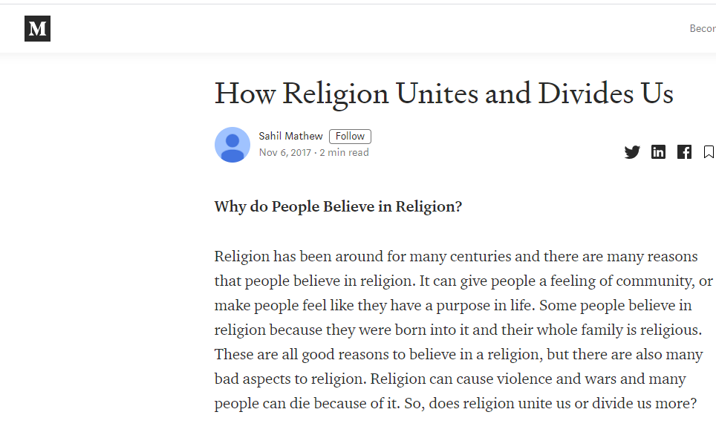

4. Academics
https://www.youtube.com/watch?v=IN3wkG1s4TA
Karen Armstrong, Author of Fields of Blood: Religion and the History of Violence
‘Religion like anything...can go bad. You can have bad art and you can have bad religion. We just have a brilliant way of fouling things up... If we just put it down as a dangerous thing or say there’s some inherent bias in Islam that pushes people towards [violence] - no more is that true in Islam that it is of secularism, Christianity, Judaism. Any ideology – be it religious or secular – has its fanatics. Christianity has behaved atrociously in the past, and indeed has secularism. We often talk about the wonderful tolerance of secularism and its love of freedom... but in fact it’s been very violent in its short history too. And that’s not to deny that the ideals of secularism are excellent, but they have been interpreted in an extremely brutal way... I do think that over time, religion, like art, like so many other ideologies has enriched human life, as well as damaged it.’

https://www.youtube.com/watch?v=g6U0Bvsrn8o
Richard Dawkins, Evolutionary biologist and well-known atheist
‘Journalist: Karen Armstrong... says it’s too easy in a sense to say [violence] is based on faith or religion but it’s the intersection of faith and religion with politics, or nationalism, or historical grievances. That it’s not the religion itself...
Dawkins: I think any kind of identity politics can have that affect and nationalism [can drive it]... but religion is extremely powerful in doing this because children are indoctrinated in religion from a very young age and they have this fantatical loyalty which is instilled into them from a very young age... political motivation is often important... but the role of religion is to identify which party you belong to... religion ferments hostility against the other side.’

4. Someone in your own circles: a friend/ family member/ local politician/ religious leader
Share some stories about people in your circles who have an opinion on this matter. Choose one to work on together and list some key points of their argument, before moving to the questions.

